**Certificates of Deposit (CDs) in the US banking system**

Certificates of Deposit (CDs) are a popular savings instrument in the US banking system that offer higher interest rates than regular savings accounts in exchange for keeping your money deposited for a fixed term. Here are the key points about CDs in the US:

* CDs are time deposits sold by banks, thrift institutions, and credit unions in the US that typically have a specific, fixed term before money can be withdrawn without penalty. The most common terms range from a few months to several years.
* As of 2022, there were over 4,800 FDIC-insured banks in the US. CDs are considered one of the safest savings options, as they offer fixed, guaranteed interest rates and are federally insured by the FDIC for banks and NCUA for credit unions up to $250,000.
* In exchange for the customer depositing money for an agreed term, US institutions usually offer higher interest rates than on-demand accounts. As of June 2024, the average 1-year CD rate was 3.25% APY.
* Withdrawals before CD maturity is usually subject to substantial penalties, such as loss of up to 12 months' interest on a 5-year CD. This ensures it is generally not in the holder's best interest to withdraw early.
* Larger deposits of $100,000 or more, known as Jumbo CDs, are commonly bought by large institutional investors like banks and pension funds. As of 2022, there were over $1 trillion in Jumbo CD deposits in the US.
* CDs can be suitable for saving for future expenses, seeking a conservative investment, or desiring the discipline of a locked-in term. However, their returns may not keep pace with inflation, which averaged 3.8% in the US over the past 10 years.
* CDs remain a popular savings tool in the US banking system, with over $7 trillion in total CD deposits as of 2022, offering a safe, stable investment option with fixed, guaranteed returns for those willing to lock up their money for a set period. However, their liquidity is limited and returns may lag inflation.

**Current average interest rates for CDs in the US**

* As of June 2024, the national average interest rate for 1-year CDs is 1.80% APY, while the national average for 5-year CDs is 1.44% APY.
* However, the highest rates available from online banks and credit unions are significantly higher than the national averages. The top 1-year CD rates are around 5.30-5.40% APY, and the best 5-year CD rates are around 4.65-4.75% APY.
* Shorter-term CDs, such as 6-month and 1-year, are currently offering the highest interest rates, with the top 6-month CD rate at 5.40% APY. Longer-term CDs of 3-5 years have lower but still competitive rates around 4-4.25% APY.
* The Federal Reserve's recent actions have influenced CD rates, with the Fed pausing rate hikes in 2024. There is anticipation that the Fed may begin reducing rates later in 2024, which could lead to a decline in CD yields going forward.
* Factors like the financial institution, minimum deposit, and term length can significantly impact the CD interest rate an individual consumer can earn. Online banks and credit unions tend to offer the most competitive CD rates compared to traditional brick-and-mortar banks.

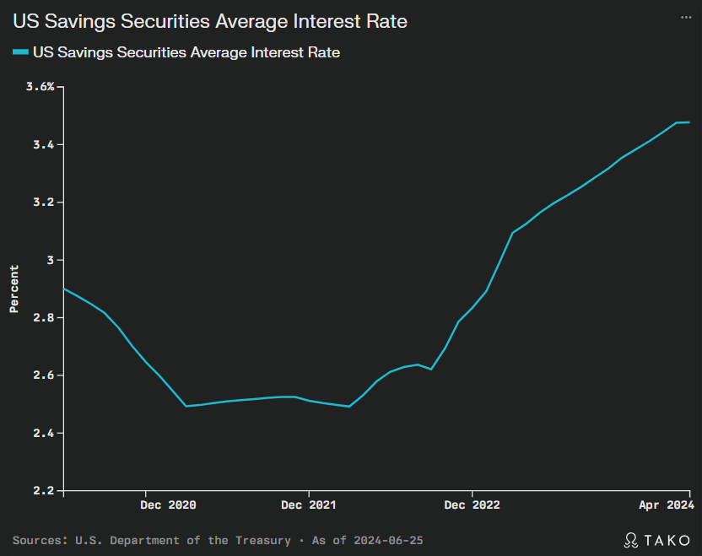

**Online banks offering the highest CD rates**

**Alliant Credit Union:**

6-month CD: 4.75% APY

1-year CD: 5.15% APY

5-year CD: 4.00% APY

**Barclays Online:**

6-month CD: 4.85% APY

1-year CD: 5.00% APY

5-year CD: 3.75% APY

**Discover Bank:**

3-month CD: 3.00% APY

1-year CD: 4.50% APY

5-year CD: 3.90% APY

**Marcus by Goldman Sachs:**

6-month CD: 5.00% APY

1-year CD: 5.00% APY

5-year CD: 3.75% APY

**Bread Savings:**

6-month CD: 4.75% APY

1-year CD: 5.15% APY

5-year CD: 4.00% APY

**Synchrony Bank:**

6-month CD: 4.40% APY

1-year CD: 4.50% APY

5-year CD: 3.90% APY

**How do online banks ensure the security of CD accounts?**

**FDIC insurance:** Online banks, like traditional brick-and-mortar banks, are required to be FDIC-insured. This means CD deposits up to $250,000 per depositor are protected in case of bank failure.

**Encryption:** Online banks use encryption technology to protect sensitive customer information like usernames, passwords, and account details when accessed through their website or mobile app.

**Multi-factor authentication:** Many online banks offer multi-factor authentication, a two-step login process that adds an extra layer of security, often by sending a one-time code to the customer's phone.

**Fraud monitoring:** Online banks monitor accounts for suspicious activity and unauthorized transactions. Customers are encouraged to set up alerts to be notified of any potential fraud.

**Secure website:** The bank's website should have a lock symbol next to the URL in the browser, indicating the site uses HTTPS encryption to protect data transmission.

**Automatic logouts:** Online banks automatically log out customers after a period of inactivity to prevent unauthorized access if the account is left unattended.

**Firewalls and antivirus protection:** On the backend, online banks use firewalls and antivirus software on their computers to prevent hacking attempts and malware infections.